Professor Dawn Fallik
ENG409 Spring 2022
dfallik@udel.edu
ENGL409- Medicine in the Media
(At Philadelphia College of Osteopathic Medicine’s cadaver lab)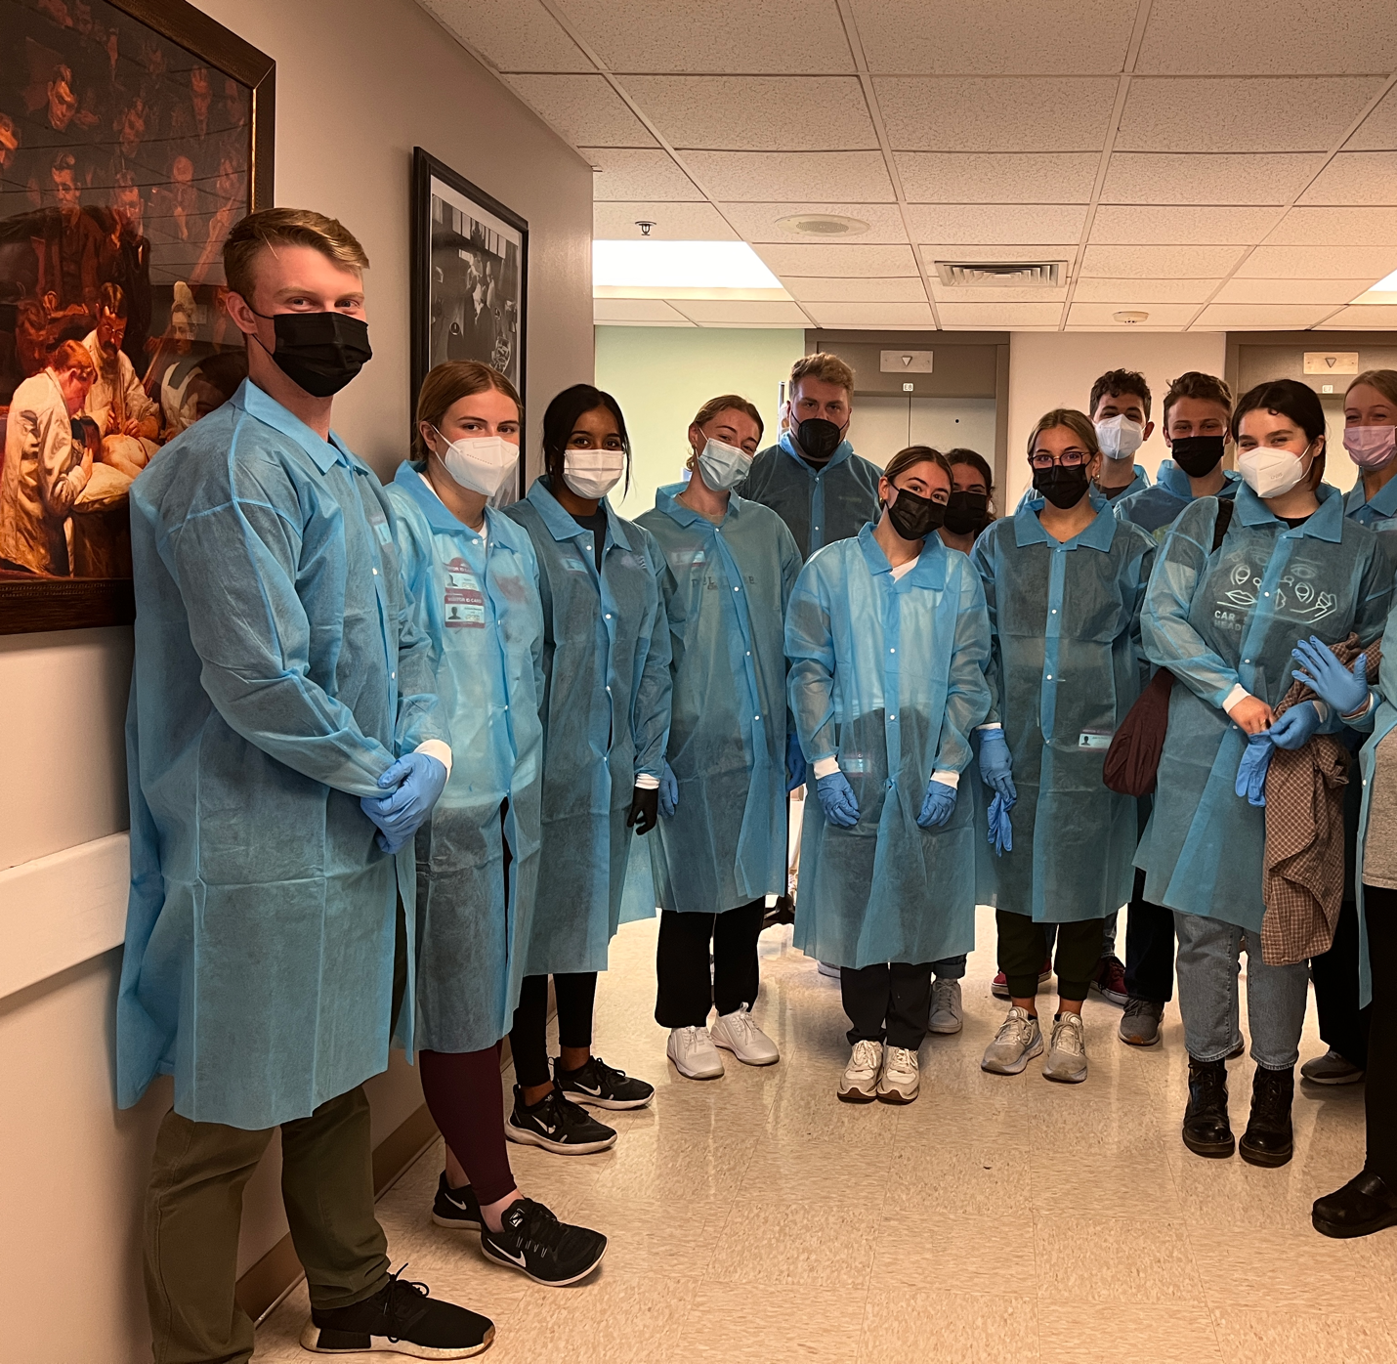
Class Time: T/Th – 9:30-10:45 - online for first month and then in person starting March 8.
Office hours: T/Th – 12:30 -1:30 drop-ins (on Zoom for first month, then in my office). If these hours don’t work for you, please email me with some times and we’ll figure something out!
ZOOM LINK (Links to an external site.) (click here)

Summary: The course will look at how various media – print, online, broadcast, social media - covers medical issues. From tracking cholera outbreaks on Twitter to the rise in medical stars like Dr. Oz, students will read, discuss and analyze what stories the media covers and the role reporters play in educating and entertaining the public.

Course objectives: By the end of the semester, students should be able to:
- Determine original sources and background materials in media sources
- Analyze the objectivity of that source, including conflict of interest, political or personal issues.
- Find credible medical sources, both for interviews and background
- Interview experts and translate their work for the general public.
- Translate an academic/medical study and interview into a general public article.
- Look at the role of social media in medical information

General Info:
Email contact: I will return all emails within 24 hours during the week. If you don’t hear from me within 24 hours, please contact me again – it might have gotten lost in the deluge.

Expectations:
Come to class. Be prepared to discuss the readings in detail. When guest speakers come to class, ask intelligent questions. I am paying attention to who asks questions and if you’re texting on your phone there will be wrath.
Think about how you could find the answer on your own for a while before asking a fellow student and then the professor. Turn assignments in on time on Canvas

Attendance: I take attendance. You are allowed two missed classes – no need to email me and tell me why, just get the notes from another student.
After that, I take off 15 points per missed class unless you have a medical note.

Late Policy: All assignments are due at 9 a.m. the day of class. Late homework and book reports are not accepted. You have ONE two-day late pass. So if it’s due Tuesday at 9 a.m., the late pass allows until Thursday at 9 a.m.
Papers turned in after the start of class will have 10 points marked off that day (tues) 20 more points (total 30) the next day (wed) and 50 points total the third (thursday.)

If you have Canvas drama, please contact IT Support Center at (302) 831-6000, M-F, 8 a.m–5 p.m. or http://www.udel.edu/it/help/request/ (Links to an external site.)

DO NOT EMAIL ME YOUR HOMEWORK.
DO NOT EMAIL ME YOUR HOMEWORK.

Assignments: This class will (mostly) be divided into two-week segments. Each segment will include multiple readings, some videos and a writing assignment.
All assignments will be due on Canvas.
*Please keep the confirmation email Canvas sends in case there is a problem.
.
Main assignments (possibility of one more)
- HONY interview – 50
- Book Analysis – How Doctors Think – 100 points
- Book Analysis – Stiff – 100 points
- Study Story -100
- Wellness review – 100
- Social media Pandemic analysis – 100
- Alumni Q and A
- Replacement assignment - A Q and A with an expert in the medical field. – 100 points. Subject must be approved by Professor Fallik before the assignment you want to replace.

Class schedule: This will change. Updated 3/20
Readings are all on Canvas, please have read the Tuesday readings before Tuesday’s class, ditto Thursday.
Class schedule: This will change.
Readings are all on Canvas, please have read the Tuesday readings before Tuesday’s class, ditto Thursday.

Week 1: What is medical journalism? (Feb 8/10)
- First day of class – What is newsworthy?
Tuesday – Interview basics

Week 2: Writing for People (Feb 15/17)
Tuesday: - sources: who are they/ How to find them?
Due Tuesday: HONY health interview
Thursday: Guest speaker: Trebs Thompson

Week 3: How Doctors Think (22/24)
Tuesday: Bring Book to class
Thursday: Looking at medical book reviews

Week 4: Study story part 1 (March 1/3)

Tuesday: Why do we cover studies so much? What’s a pre-print?
Thursday: Bring a study story you found to class

Week 5: MOVE TO IN PERSON Study Story part 2 (8/10)
Tuesday: Guest speaker: Dr. Gregory Hicks, physical therapy
Thursday: “Hey Martha” medical stories.

Week 6: The other pandemic: AIDS in America
Tuesday: How the media covered HIV and AIDS
Thursday: no class - watch “How To Survive A Plague” OR “5B”

Week 7: Pandemic Part 2 March 22/24
Tuesday: How social media is changing the face of HIV/AIDS
Thursday: Guest speaker : Larry Benjamin, director of Philadelphia’s Mazzoni Center

Week 8 - spring break

Week 9: April 5/7
It’s all Goop to Me – scams in medicine

Week 10 – April 12/14 – College students and mental health
Media analysis due:

Week 11 – April 19/21 - Loneliness and Gen Z

Week 12 – April 26/28-
April 26- Mary Roach: Stiff discussion

April 28 - Alumni interview review

Week 13 - May 3/5
May 3- Cadaver lab field trip
Book analysis due
May 5 – public health data – Doctors with dollars

Week 14 – May 10/12
May 10 - last day!
May 12 – alumni interview due

